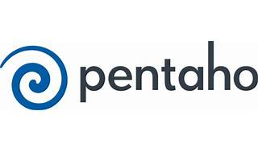



Explore

**Pentaho** is a **business intelligence (BI) software** that provides data integration, OLAP services, reporting, information dashboards, data mining, and extract, transform, load (ETL) capabilities. [It’s headquartered in **Orlando, Florida**1](https://en.wikipedia.org/wiki/Pentaho)[2](https://ai-jobs.net/insights/pentaho-explained/).

Here are **five free learning resources** where you can explore Pentaho:

1. [**Pentaho Tutorials by Hitachi Vantara**](https://www.hitachivantara.com/en-us/products/pentaho-plus-platform/data-integration-analytics/pentaho-tutorials.html): These tutorials cover building data pipelines, installation, and more.
2. [**Udemy Course: Learning Pentaho**](https://www.udemy.com/course/learning-pentaho/): Learn to create a BI Server, transform data, and work with databases using Pentaho.
3. [**Class Central Course: Learning Pentaho**](https://www.classcentral.com/course/udemy-learning-pentaho-87068): Create a BI Dashboard from scratch using Pentaho.
4. [**Pentaho Courses on Class Central**](https://www.classcentral.com/subject/pentaho): Explore various Pentaho courses and certifications from different platforms.
5. **Pentaho Community Edition**: Access the community edition of Pentaho for hands-on learning.

Happy learning! 🚀📊